Chapter 2, Solution 68

(a) 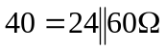
i = 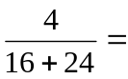100 mA
- 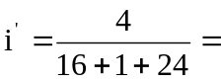 97.56 mA
- % error = 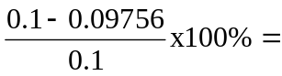2.44%

